**Use these tools to keep up with all the things happening in our classroom!**

**Have Internet Access?**

Visit our classroom website regularly to see pictures, student work, and much more! Our classroom website is a great tool to keep up to date with what is going on in our classroom and school!

**Simply visit:**

**pellston.weebly.com**

**Want the News?**

Read our classroom newsletter! Classroom newsletters are full of information about our learning, upcoming events, and important announcements!

**Newsletters are sent home in Friday folders. You can also print them or read them online on our classroom website.**

**Have Texting?**

Sign up for our classroom text alerts. Receive reminders for fieldtrips, test notices, and upcoming events.

**Simply text:**

**@wolford**

**to**

**1 (985) 231-0761**

**Follow the instructions in the reply text.**

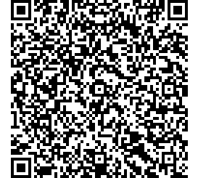

**Have a Smart Phone?**

Download a QR Reader. There are many free versions. I recommend the QRReader app.

Scan this QR Code to instantly save my contact information!

Mrs. Emily Wolford

Pellston Elementary School Fourth Grade

**Want Email Alerts?**

Sign up for our classroom email alerts. Receive reminders for fieldtrips, test notices, and upcoming events. It is quick and easy to stay in touch!

**Simply email:**

**wolford@mail.remind.com**