**C:\Users\Dameon\AppData\Local\Microsoft\Windows\Temporary Internet Files\Content.IE5\YIKI2A1X\MC900412684[1].wmfC:\Users\Dameon\AppData\Local\Microsoft\Windows\Temporary Internet Files\Content.IE5\YIKI2A1X\MC900412684[1].wmfCLASS ROUTINES**

**Mrs. Wolford’s Fourth Grade Class**

**2014 – 2015**

Welcome to fourth grade! I am very excited about the upcoming year and I know it will be filled with laughter and learning. This year, you will be traveling between two classrooms as you learn all we have to teach. I will be teaching all of the Language Arts, including reading, writing, and word work. Mrs. de Castro will be teaching math, science, and social studies. Since you will be working with two different teachers, organization is going to be very important! I wanted to take some time to share with you and your parents some routines and information that will be helpful for the upcoming year.

* **Class Website:** I believe in providing excellent communication to parents and students in my class. You will find our classroom website is loaded with useful information. Our website is always up to date so you can be sure what you are reading is accurate. You will find parent announcements, homework assignments and handouts, our spelling lists, weekly stories, a calendar of events, curriculum, helpful web sites to reinforce our grade level skills, photos of classroom projects and memories, classroom projects, our schedule, and much more! Be sure to bookmark our site or add it to your favorites list for quick access. You can visit our classroom website at **pellston.weebly.com**. You can also access it from the Pellston school homepage.
* **Classroom Newsletter:** Our classroom newsletter will be sent home in Friday Folders each week. You can also find it on our classroom website on the Classroom News page. The newsletter contains important information about upcoming events, assignments, and announcements. You will also find information about our learning for the week and the upcoming weeks. Spelling words for the following week will also be provided in the newsletter. Please take a few minutes every Friday to read the newsletter with your child.
* **Classroom Alerts from Remind 101:** Remind101 is a free, one-way text messaging and email system that we use in our classroom. With Remind101, all personal information remains completely confidential. These alerts are a great way to stay informed about important information, upcoming events, due dates, and more! There are two ways you can receive these alerts, through text messages or email.

If you have texting on your phone, you can sign up to receive text alerts by simply texting: **@wolford**  to (985) 231-0761. Then, follow the easy instructions in the reply text message. It is that easy to stay informed!

If you want email alerts, simply email  **wolford@mail.remind.com** .

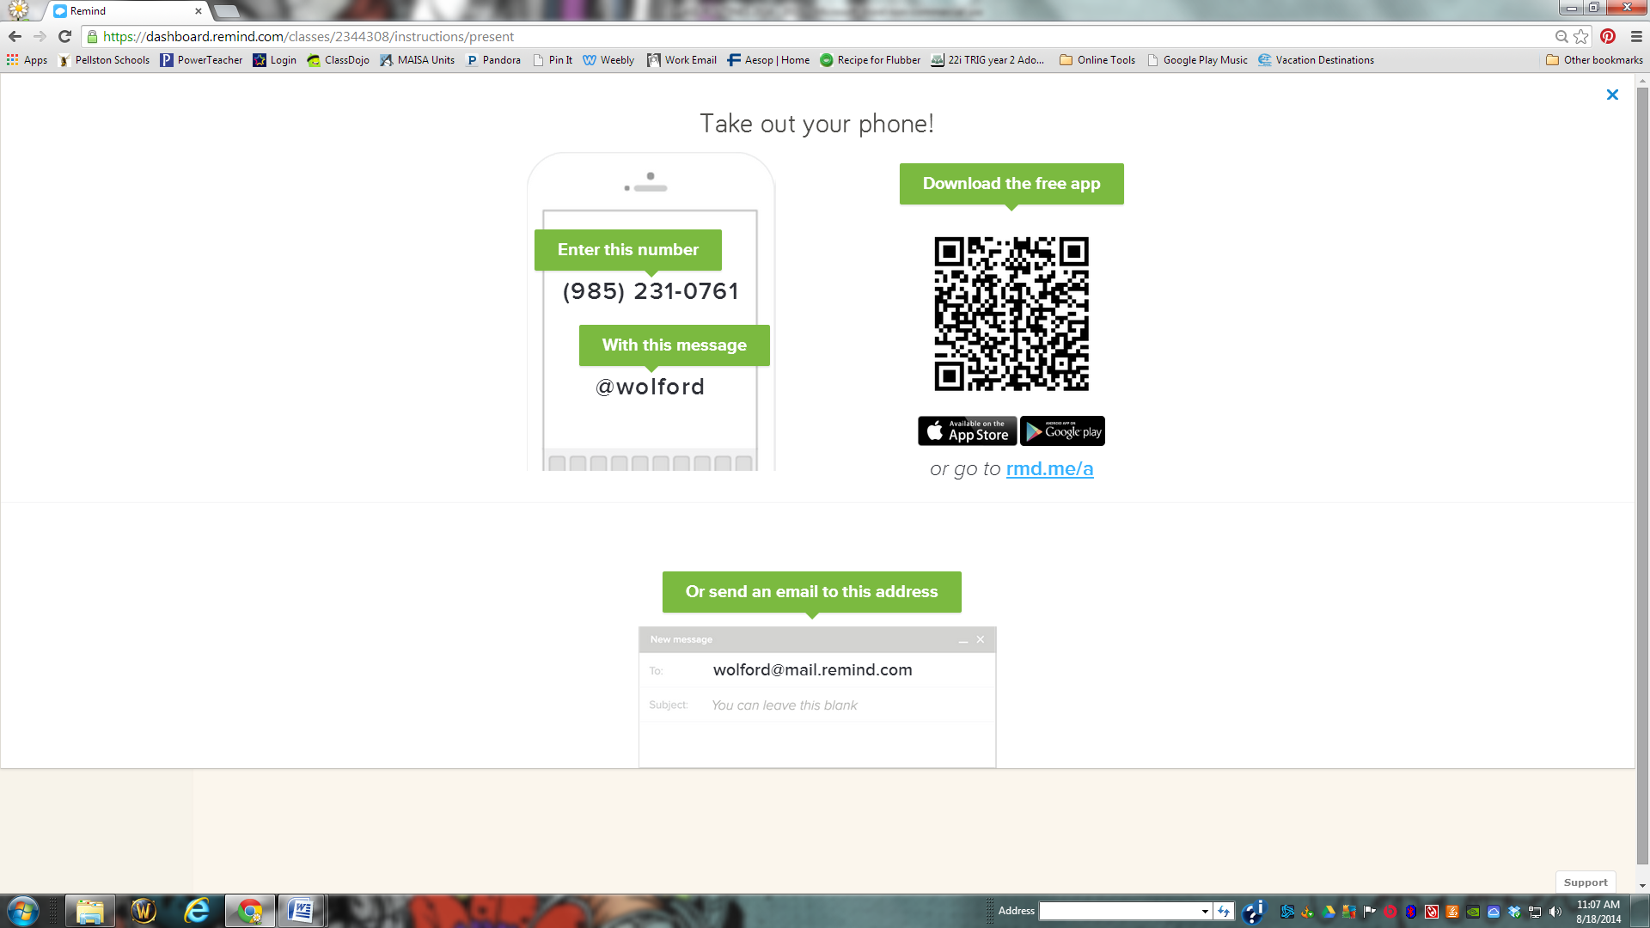

*You can opt out of emails at any time by replying, 'unsubscribe @wolford' in the subject line.*

*You can opt out of messages at any time by replying, 'unsubscribe @wolford'.*

* **Contacting Mrs. Wolford:** I check my email throughout the day and evening. It is a great way to get feedback to your questions or comments, and I encourage you to contact me this way.

**Important Note** – *If you have a message you need to get to your child before the end of the day – please call our school secretary at (231) 539-8421 and leave the message with her.*

My e-mail address is ewolford@pellstonschools.org and I also receive my school e-mail at home, so feel free to send me a note even after school hours. My school phone number is **(231) 539-8421 ext 241** and if I am unable to answer, it has voicemail capabilities. If you should need to get in touch with me outside of school hours, you may also call my cell phone at **(231) 330-1605** or text message me.

* **Homework Folders:** Your child was provided with a blue folder with many helpful study resources on it. This will be our home-to-school connection folder for all incomplete work, homework and school correspondence. It should come home nightly and come back each day. In the event that your child should lose their folder, it will be their responsibility to bring in a new one. Completed assignments from the previous week will come home on Fridays in a separate Friday Folder. Please look for your child’s homework folder each night to make sure they do not have any work to complete for the evening.
* **Homework:** Students are responsible for studying their spelling words and reading nightly. In addition, students are responsible for completing any assignments that are not finished in class at home. These assignments will be brought home in the students' homework folders. Assignments should be completed and returned the next day for full credit. Quarterly projects will also be assigned.
* **Spelling:** We use the spelling program that goes with our Reading Street reading series. Students will be given a list of 20 spelling words every Friday. This list will be in the newsletter and available on our classroom website. Students will work with the words throughout the week and with the spelling rule, pattern, or device that is being taught that week. It is expected that students study these spelling words throughout the week at home as well. There are many good spelling activities that can be found on our website in the links section and with the lists in the curriculum section. On Friday, students will take the test over the 20 assigned words. In addition, there will be 5 – 6 “bonus” words that can be spelled using the rule, pattern, or device that was taught throughout the week. These words are extra credit. Students do not get marked down for attempting them.
* **Absences:** When your child is absent, he or she is responsible for making up the work that was completed while they were gone. Students will find their missing assignments in the absent folder. Students have the same number of days they were gone to make up the work. For example, if a student misses 2 days of school, s/he would have 2 days after s/he returned to school to make up the work. ***Please note that much of our classroom activities cannot be done at home (group work, discussions, in‐class activities, buddy class activities, etc), so regular attendance is encouraged.***
* **Grading:** Students will receive report card grades of an A, B, C, D, or F. Daily assignments, however, usually are a percentage grade. The grading scale is as follows:

96 – 100 A+

93 – 95 A

90 – 92 A-

86 – 89 B+

83 – 85 B

80 – 82 B-

76 – 79 C+

73 – 75 C

70 – 72 C-

66 – 69 D+

63 – 65 D

60 – 62 D-

Below 60 F

Other grades which you may see include:

* + T = Turned In
  + O = Outstanding
  + ✓ = Satisfactory
  + P = Demonstrates progress
  + N = Needs improvement
  + CT = Completed Together

I update Powerschool frequently, but most often on Sundays. You can check Powerschool anytime to see if your child has any missing assignments or to see how they are doing in class. If you do not know your Powerschool username and password, please contact the school office at (231) 539-8421. If you have any questions about your child’s grades, please contact me and I will be happy to discuss your child’s progress at my earliest convenience.

* **Effort:** Students are always expected to turn in their best work in their best handwriting. If an assignment is illegible or not the student’s best work, they may be marked down or asked to redo the assignment.

**Students have the opportunity to correct any score of a D or lower on classroom assignments** to make sure they understand what was being taught and to have their grade raised. To do this, you should make the corrections on the paper in pen or colored pencil. Do not erase the original answer. Next to the new answer, explain how you know that this answer is correct. Students will receive 1/2 credit for each new correct answer allowing them to raise the grade of the assignment to 80%. Students have one week after the assignment is returned to correct it and have it rescored.

* **Behavior:** To provide a safe and pleasant environment, our Pellston Elementary School rules are: be respectful, be responsible, be safe, and be caring. Students will be taught the rules by all staff through modeling, direct instruction, and positive reinforcement for good choices. For great behavior, your child may bring receive a “Bee ticket” and be entered into a school wide drawing.
* **Classroom Incentives:** When students are being good role models, following our four “Bees”, and showing that they are great fourth grade students, they will be verbally recognized and may earn classroom tickets that can be spent in our classroom for 10 minutes of computer time, lunch with the teacher and friend, a prize from our reward drawer, and more.
* **Field Trips:** We will take several field trips over the course of the year. Stay tuned for more information as we plan for the year. If you would like to chaperone, be sure you have the district’s volunteer form already filled out. It takes approximately 2 weeks to become an approved volunteer. More time is needed at the beginning of the school year so be prepared and turn in your form early. If you need to fill out the form, please pick it up at the school office or download it from the Volunteer page on our classroom website.
* **Parent Volunteers:** I cannot imagine teaching without the assistance of parent volunteers! Parents play a critical role in the functioning of our classroom. I appreciate any support and help you can offer. In order to help in the classroom or chaperone on field trips, all volunteers must fill out the district volunteer form and be approved at least two weeks prior to volunteering. This form may be requested from our office. We encourage you to fill out the form to keep your options open throughout the year. If you would like to help out, please let me know your talents and skills and I’ll put you to work! As a note: I always appreciate helpers in the classroom. If you are intending to spend some time volunteering in the classroom, please let me know in advance so that I can have things prepared for you. Thank you!
* **Water Bottles:** Students are encouraged to bring and use a plastic water bottle with a *spill-proof lid*. Students are not allowed to get drinks during lessons from the drinking fountain, so it is recommended that they bring a water bottle with them. Water bottles should have the student’s name somewhere on it. *Please do not send any drinks other than water.*
* **Snack:** Students will *usually* have a working snack time in the afternoon. They may bring a ***healthy snack choice*** that they can eat while working quietly. These snacks may include granola bars, fruit, veggies, and so on. Please do not send candy or other sugary treats for snack.
* **Our Daily Schedule:** Our days are packed with learning and some fun too!

Some important times you may wish to know are:

Full Day Start and End Times: 8:15 – 3:15 Half Day Start and End Times: 8:15 – 11:35

Lunch time: 11:15 - 11:45

Please be sure your child has clean shoes for gym.

**Our specials schedule is as follows:**

|  |  |  |  |  |
| --- | --- | --- | --- | --- |
| **Monday** | **Tuesday** | **Wednesday** | **Thursday** | **Friday** |
| Art and Computers | Physical Education | Art | Computers | Physical Education |

Thank you for taking the time to review these procedures and routines. If you have any questions, please let me know and I’ll be happy to answer them! I look forward to the upcoming year!

Sincerely,

Mrs. Wolford

I have reviewed the classroom procedures and routines with my child.

Signature: _____________________________________________________________________________________________________________________________________________

Phone Number: __________________________________ Parent E-mail Address: ________________________________________________________